 | 

VALUE CONTROL MAJOR RELEASE
From Value Drift
to Accountable Action
The Business Value of Songlines Value Review Cases

A governed operating model that turns material Value Drift into named ownership, evidence-led review and authorised human action.
Executive White Paper | Version 1.0 | September 2026
Prepared by Cetus AI Pty Ltd | Public
CetusAI.com.au | hello@cetusai.com.au
This paper describes shipped product capability and a proposed connector roadmap. It does not provide accounting, legal or audit advice.

Executive Summary
Enterprise AI programs are moving beyond experimentation into portfolios of operational systems, copilots and agents. As that portfolio grows, the central management question changes. It is no longer enough to ask whether a use case once produced a positive result. Leaders must know whether the assumptions, evidence, costs and operating conditions supporting an approved value conclusion still hold—and what the organisation should do when they do not.
Songlines Value Control already addresses the first part of this problem through Value Contracts, a temporal Value Evidence Graph and deterministic Value Drift. Together, these capabilities define what an initiative must prove, preserve the evidence behind each value state and detect when a previously accepted condition materially changes.
The Value Review Cases major release closes the operational gap that follows detection. A material drift condition can now become a named, time-bound and governed investigation with accountable ownership, evidence requests, advisory finance review, escalation, human disposition and immutable history. The case does not rewrite ROI, reverse finance approval or make a portfolio decision automatically. It creates the controlled path by which authorised people can reach and explain that decision.
The release changes Value Control from a measurement and alerting capability into an accountable operating workflow for protecting the quality of AI investment decisions over time.

For executives, the value is practical. Material exceptions are less likely to remain unowned. Finance receives a clearer separation between evidence, advisory review and formal recognition. Portfolio leaders gain an explicit path from “something changed” to Scale, Optimise, Review or Retire. Governance and assurance teams can reconstruct who acted, what they considered and which authoritative record ultimately changed. Architecture teams can adopt the workflow without replacing the systems that already hold operational, cost, service-management or finance evidence.
The release also defines a proposed enterprise connector architecture for future real-source integration. It is designed as a customer-controlled provenance and decision sidecar using push, export and read-only access patterns. The roadmap covers OpenTelemetry and CloudEvents, MuleSoft, FOCUS cost data, Azure OpenAI, AWS Bedrock, Salesforce, SAP and ServiceNow. These connectors are proposed implementation phases, not live integrations.

Contents
Executive Summary | Why accountable review matters
1 | The Business Problem: Value Can Change After Approval
2 | What the Major Release Changes
3 | The Six-Stage Operating Model
4 | Business Outcomes by Executive Stakeholder
5 | How the Three Flagship Capabilities Work Together
6 | From Alert Management to Capital Discipline
7 | Enterprise Evidence Without Architectural Friction
8 | A Practical Adoption Model
9 | Measuring the Business Value of the Release
10 | What the Release Does Not Claim
 | Conclusion and About Cetus AI

1. The Business Problem: Value Can Change After Approval
An AI business case is usually approved at a point in time. It reflects an expected workload, a baseline, an operating model, a set of cost assumptions, an attribution approach and a forecast of benefit. Once deployed, each of those conditions can change.
A model may be replaced. Routing may shift to a more expensive provider. Adoption may fall below plan. Human review or exception handling may increase. An approved evidence source may stop refreshing. A process change may invalidate the original comparison. The business outcome may still be positive—but the evidence supporting the prior conclusion is no longer the same.
Traditional dashboards are good at displaying current metrics. Alerting systems can identify thresholds. Finance systems can record approved amounts. Service-management platforms can coordinate tasks. The gap is an operating mechanism that connects a material change to the right owner, the right evidence, the right review authority and a documented human decision.
Without that mechanism, enterprises face four recurring problems:
Operating gap | Business consequence
Material value exceptions have no named owner | Issues remain visible but unresolved, creating delay and ambiguity.
Evidence is collected through email, meetings and local files | Decision reconstruction is slow and dependent on individual memory.
Operational evidence and finance recognition are blurred | Teams risk treating correlation, telemetry or cost movement as proof of realised benefit.
Decisions are recorded without a durable review path | Boards, executives and assurance functions can see the decision but not the complete reasoning chain.

The consequence is not simply reporting inefficiency. It is weaker capital allocation. Organisations may continue funding an initiative whose evidence has deteriorated, pause an initiative whose apparent variance has a reasonable explanation, or spend weeks rebuilding the information required for a decision that should have been available as part of the operating process.

2. What the Major Release Changes
Value Review Cases turns Value Drift into governed work. A case can be created from one or more material drift events associated with the same use case, or opened manually when a documented concern requires investigation. Each case receives an organisation-scoped case number, accountable owner, priority, due date and controlled status.
The workflow then coordinates the investigation without collapsing distinct business authorities. Evidence contributors can respond to named requests. A finance reviewer can record an advisory conclusion. Administrators and owners control assignment, escalation, lifecycle and disposition. Existing finance-validation and portfolio-decision actions remain authoritative.
Release capability | Business outcome enabled
Accountable case queue | Gives executives and control owners a single view of material value issues, ownership and due status.
Multi-drift investigation | Allows related symptoms to be considered together without losing the original source snapshots.
Named evidence requests | Replaces informal follow-up with explicit questions, recipients, due dates and response provenance.
Advisory finance review | Brings finance into the case while preserving formal recognition as a separate authorised action.
Controlled disposition | Requires a human rationale and can link the case to an existing validation or Scale, Optimise, Review or Retire decision.
Immutable activity history | Preserves who changed ownership, requested evidence, reviewed finance, escalated or disposed the matter.
Deterministic due escalation | Makes delay visible using consistent due-soon, due, overdue and materially-overdue thresholds.
Temporal Evidence Graph projection | Connects the case to its source drift, requests, reviews and authorised records without asserting causation.

The practical difference is accountability. A drift alert says that a controlled condition changed. A Review Case says who owns the investigation, what evidence is missing, when action is due, where finance input is required and how the organisation reached its conclusion.

3. The Six-Stage Operating Model
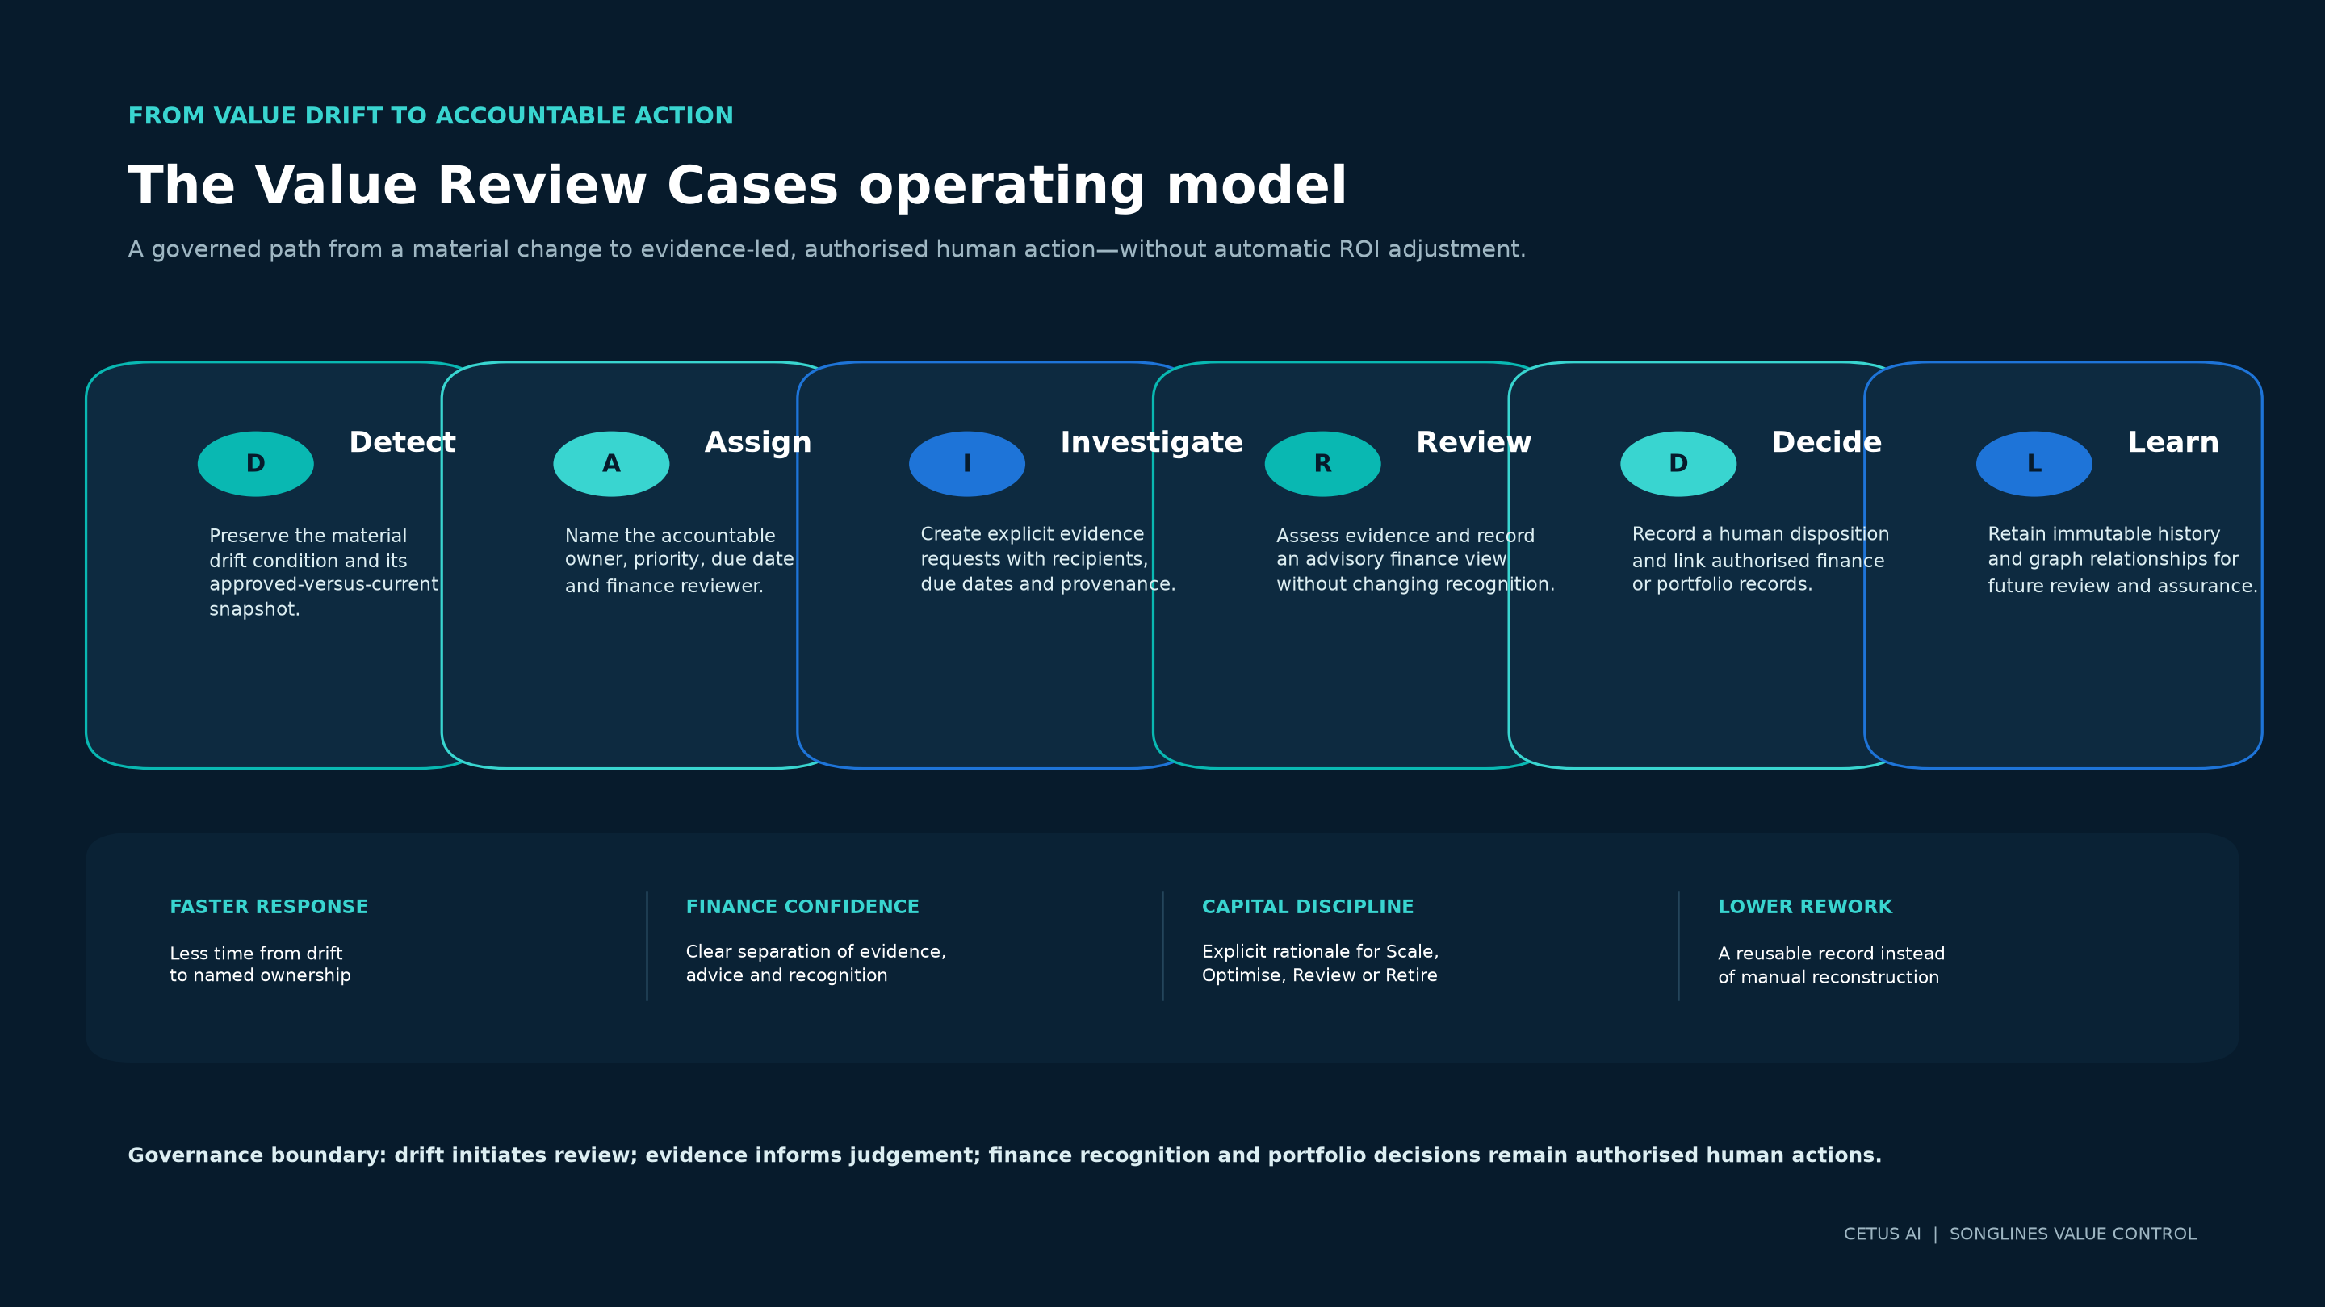
Figure 1. Songlines Value Review Cases operating model: Detect, Assign, Investigate, Review, Decide and Learn.

Detect
Songlines identifies a material change against an approved Value Contract or evidence condition. The source drift remains unchanged and its approved-versus-current snapshot is preserved. Detection initiates review; it does not assert that value has been lost.
Assign
The issue becomes an organisation-scoped case with a named owner, priority and due date. Where finance input is expected, an accepted same-organisation finance reviewer is assigned. This prevents material exceptions from remaining “everyone’s problem and no one’s responsibility.”
Investigate
The owner frames the review, links relevant drift conditions and creates evidence requests. Each request identifies what is needed, who is responsible, when it is due and how the response will be referenced. Evidence remains connected to its source and classification.
Review
Contributors and reviewers assess the evidence. Finance can record an advisory conclusion such as validation current, revalidation recommended, insufficient evidence or no finance change. The case cannot create or amend recognised benefit.
Decide
An authorised admin or owner records the case disposition. If an established finance-validation or portfolio-decision workflow has produced an authoritative record, the case may link it after same-organisation and same-use-case validation. The decision remains human and explicit.
Learn
The immutable timeline and temporal Evidence Graph preserve the complete path from drift detection through evidence, review and outcome. This creates a reusable record for portfolio review, management reporting and future operating-model improvement.

4. Business Outcomes by Executive Stakeholder
Chief Financial Officer and Finance Leadership
The release protects the distinction between an operational observation and finance-recognised value. Cost changes, telemetry and evidence responses can inform a review, but they do not automatically change a validated amount. Finance can see which claims require attention, record an advisory view and require the established finance-validation process where formal recognition must change.
The business outcome is stronger confidence in the portfolio’s value states. Finance can spend less time determining whether a number came from a forecast, an observed outcome, an attribution decision or an approved validation because those states remain explicit.
Chief Information Officer and Transformation Leadership
CIOs gain a governed exception-management layer across the AI portfolio. The queue shows which initiatives have material drift, who owns the response and whether evidence, finance review or a decision is pending. This supports more disciplined prioritisation without requiring the CIO to interpret every technical signal personally.
The business outcome is faster movement from detection to an owned next step, coupled with less risk that a dashboard alert becomes an unresolved management concern.
AI Governance, Risk and Assurance
Governance leaders gain an append-only record of assignments, transitions, evidence requests, responses, advisory reviews, escalation and disposition. The Evidence Graph shows explicit relationships between the case and its source records while preserving non-causation language.
The business outcome is greater explainability. Reviewers can inspect the chain of reasoning without treating the platform as an audit opinion, certification or substitute for the organisation’s assurance functions.
Business and Portfolio Owners
Business owners gain a structured path to explain why conditions changed and what should happen next. A case may conclude that the current value position remains appropriate, that evidence should be remediated, that finance revalidation is recommended, that a control action is required, or that an existing portfolio decision should be linked.
The business outcome is more credible investment stewardship. Decisions are not limited to “continue” or “stop”; the operating model supports monitored continuation, optimisation, evidence remediation and controlled reassessment.
Enterprise Architecture and Platform Teams
The release is designed to coexist with the enterprise stack. Review Cases do not require Songlines to replace ERP, CRM, integration, observability, FinOps or service-management platforms. Those systems remain authoritative for their native records.
The business outcome is reduced adoption friction. Songlines can add the missing value-governance layer while preserving existing platform investments and accountability boundaries.

5. How the Three Flagship Capabilities Work Together
The major release completes the operating connection between the three flagship capabilities.
Flagship capability | Management question | Business role
Value Contract | What must this AI initiative prove before it is considered decision-eligible? | Establishes the approved promise, evidence standard, owners and thresholds.
Value Evidence Graph | Why is this value state credible, and what changed since the last decision? | Connects source evidence, calculations, approvals, drift, review and decisions through time.
Continuous Reconciliation, Value Drift and Review Cases | Does the approved conclusion still agree with current conditions, and who must act when it does not? | Detects material change and turns it into accountable, time-bound human review.

The combined model moves Value Control beyond retrospective ROI reporting. It creates a continuous chain from the original investment promise to evidence, finance recognition, change detection, accountable review and authorised action.
The management objective is not to produce a larger ROI number. It is to improve the quality, timeliness and explainability of AI investment decisions.

6. From Alert Management to Capital Discipline
Value Review Cases is valuable because it influences how the enterprise allocates management attention and capital. It provides a consistent way to distinguish between a temporary data issue, an evidence-quality problem, a material operating change and a conclusion that genuinely requires finance revalidation or portfolio action.
This supports five forms of capital discipline:
Discipline | How the release supports it
Protect approved investment cases | Material changes are brought back to accountable review before leaders continue relying on an outdated conclusion.
Prioritise scarce review capacity | Severity, due state and finance-review status help leaders focus on the most consequential unresolved cases.
Avoid premature write-offs | Drift is investigated rather than treated as automatic proof that value disappeared.
Avoid unchallenged continuation | An approved value claim does not remain unquestioned when its evidence or operating conditions materially change.
Create a reusable decision record | Future funding and assurance reviews can start from the retained evidence and reasoning rather than reconstructing the past.

The release does not promise a financial return. Its value lies in improving the control environment around investment decisions. Enterprises can then measure whether that improved control reduces review delays, evidence-reconstruction effort and the proportion of material exceptions without an authorised outcome.

7. Enterprise Evidence Without Architectural Friction
Accountable review becomes more valuable as evidence arrives from the systems where work actually occurs. The proposed connector architecture is therefore designed as a provenance and decision sidecar, not as mandatory middleware through which every AI request must pass.
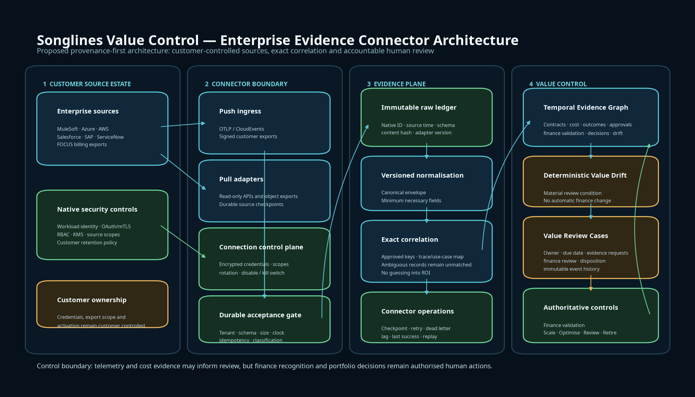
Figure 2. Proposed Songlines Value Control enterprise evidence connector architecture.

Customer systems can push approved telemetry, expose controlled exports or authorise read-only access. Songlines would preserve source-native identities, timestamps, schema versions and hashes; create versioned normalised records; correlate only through exact or explicitly approved mappings; and retain unmatched records for reconciliation.
OpenTelemetry provides distributed trace concepts and semantic conventions for CloudEvents, while FOCUS provides a common billing-data schema. These standards improve portability but do not replace the identity and authority of the source system.[1] [2] The proposed design therefore separates three questions: what the source recorded, which Songlines use case the record relates to, and whether the resulting value claim is decision-eligible.
Evidence source family | Proposed business contribution | Boundary that remains
MuleSoft and OpenTelemetry | Workflow execution, trace and integration evidence from existing orchestration layers. MuleSoft documents an OpenTelemetry-compatible telemetry export path.[7] | Exported activity supports lineage; it does not prove business benefit.
FOCUS and FinOps exports | Normalised cost and billing-period evidence across providers.[2] | Cost evidence can support reconciliation but cannot validate benefit.
Azure OpenAI | Request, deployment, model, token and service-specific operational metrics through customer-configured Azure monitoring.[3] | Connection health and telemetry coverage do not prove outcome quality.
AWS Bedrock | Customer-configured invocation metadata from CloudWatch Logs or S3; invocation logging is disabled by default.[4] | Prompt and response bodies remain excluded by default and require a separate sensitive-data path.
Salesforce | Event monitoring and approved agent trace evidence, with source limitations made visible.[5] | Late, duplicate or subscription-limited records require checkpoint and completeness controls.
SAP BTP | Audit events retrieved with source identifiers, time windows and paging controls.[6] | SAP remains authoritative for its native records.
ServiceNow | Read-only task or case evidence, with optional later linkage to controlled work items.[8] | ServiceNow remains the service-management system of record; write access would require a separate credential and operation allowlist.

No connector becomes available because a common interface exists. Each source requires implementation, security review, customer configuration, source-specific contract testing, reconciliation controls, operational runbooks and visible limitations.

8. A Practical Adoption Model
The fastest way to realise the operational value of Review Cases is to begin with a small, material portfolio rather than attempt enterprise-wide ingestion on day one.
Establish the decision scope
Select three to five AI initiatives with approved Value Contracts or well-understood investment hypotheses. Confirm the accountable business owner, finance authority, evidence sources and decision thresholds for each. Success at this stage is clarity: the organisation can explain what each initiative must prove and who owns the conclusion.
Operate the review workflow
Use current Value Drift conditions and one or two manually documented concerns to exercise the case lifecycle. Measure the time from detection to ownership, the age of open evidence requests, the time to an advisory finance view and the percentage of cases that reach an authorised disposition.
Introduce real-source evidence deliberately
Add one operational source and one cost source using the proposed connector contracts. Preserve native identifiers and keep ambiguous records outside calculations until reconciled. The initial goal is not broad connector coverage; it is a dependable evidence path that can be explained end to end.
Review the operating model
After an initial review cycle, assess whether case priorities, default due intervals, evidence request types and escalation recipients match the organisation’s governance model. Adjust operating rules with accountable approval rather than embedding unreviewed assumptions in automation.

9. Measuring the Business Value of the Release
The release should be evaluated through decision-quality and operating-efficiency measures rather than headline ROI claims.
Outcome measure | Desired direction | What it indicates
Time from material drift to named owner | Down | The organisation converts detection into accountability faster.
Time from case creation to first material evidence response | Down | Evidence collection is becoming more operational and less ad hoc.
Percentage of active material cases with an accepted owner and due date | Up | Fewer exceptions remain unowned.
Percentage of finance-review cases with an explicit advisory conclusion | Up | Finance participation is visible and reproducible.
Percentage of dispositions linked to an authoritative validation or portfolio decision when required | Up | Case outcomes connect to the proper decision system.
Percentage of closed cases with complete mandatory evidence requests | Up | Closure quality is improving.
Manual effort to reconstruct a value decision pack | Down | Provenance and activity history are reducing rework.
Percentage of source records matched through exact or approved mappings | Up | Evidence correlation is becoming more reliable without guessing.
Number of incumbent enterprise systems replaced | Zero by design | Songlines remains an additive value-governance layer.

These measures should be baselined within each organisation. The paper intentionally does not prescribe universal targets because materiality, review cadence, evidence availability and risk appetite vary by portfolio and operating environment.

10. What the Release Does Not Claim
The value of the release depends on disciplined boundaries.
A Review Case is not proof that value was lost. It does not establish causation from temporal correlation. It does not automatically change a calculation, recognise benefit, reopen finance approval or record a Scale, Optimise, Review or Retire decision. Evidence acceptance means a case request has been answered; it does not mean finance has accepted the benefit. Closing a case does not acknowledge every user’s alert or silently resolve the source drift condition.
The connector architecture is proposed. The release does not claim live source-specific connectors, universal coverage, certified vendor schemas, guaranteed residency, automatic compliance, an audit opinion, realised ROI or guaranteed savings. Customer credentials and source permissions remain customer controlled, and sensitive content remains excluded by default.
These are not limitations to obscure. They are the governance design. By keeping evidence, attribution, finance recognition and portfolio authority distinct, Songlines helps leaders understand exactly what a value conclusion means—and what it does not.

Conclusion
The most important outcome of the Value Review Cases major release is not another dashboard. It is an operating mechanism for responsible follow-through.
When material conditions change, the enterprise can now preserve the original signal, assign accountable ownership, request evidence, involve finance without bypassing finance authority, escalate delay, record a human disposition and retain the complete decision history. The temporal Evidence Graph makes that path explainable. The proposed connector architecture provides a disciplined route to bring real-source evidence into the same model without replacing the enterprise systems that produced it.
This is how AI value management matures: not by assuming every forecast becomes realised value, and not by treating every variance as failure, but by ensuring that material change leads to timely, evidence-led and authorised action.
Songlines Value Control gives the enterprise a governed path from investment promise to evidence, from evidence to review, and from review to accountable action.

About Cetus AI
Cetus AI develops Songlines, an enterprise AI control platform designed to help organisations govern AI usage, evidence, economics and accountable decisions. Value Control connects Value Contracts, operational and financial evidence, progressive value states, Value Drift, Review Cases and human portfolio decisions in one governed operating model.
Cetus AI Pty Ltd CetusAI.com.au hello@cetusai.com.au
References
[1] OpenTelemetry — Semantic conventions for CloudEvents spans
[2] FinOps Open Cost and Usage Specification — FOCUS Specification 1.4
[3] Microsoft — Azure OpenAI monitoring data reference
[4] Amazon Web Services — Monitor model invocation using CloudWatch Logs and Amazon S3
[5] Salesforce — Using Event Monitoring
[6] SAP — Audit Log Retrieval API usage for subaccounts
[7] MuleSoft — Exporting telemetry data to third-party monitoring systems
[8] ServiceNow — Table API

To discuss Value Control or a governed AI value-assurance engagement, contact hello@cetusai.com.au

